Interval Tree
An Interval Tree is a specialized data structure used to store intervals (ranges) and efficiently answer questions like:
“Which intervals overlap with a given interval or point?”

What is an Interval?
An interval is a range defined by two values: [start, end]
Examples:
- [5, 10]
- [12, 20]
- [30, 40]

Why do we need an Interval Tree?
Imagine you have many intervals and you want to repeatedly answer:
- Does any interval overlap with [x, y]?
- Which intervals contain a point p?
If you check every interval, it takes O(n) time → slow.
Interval Tree reduces this to O(log n) for most queries.

Interval trees are of two types :
1️⃣ BST-based Interval Tree
This is the most common one (CLRS, GFG).
What each node stores:
- one interval → [low, high]
- max → maximum high value in its subtree
- left & right pointers
Key idea:
The tree is ordered by low, and max helps skip useless subtrees while searching.
Example node: [2,6], max = 8
Used for:
- interval overlap queries

2️⃣ Elementary-Interval-based Interval Tree
More theoretical / computational geometry
What nodes store:
- internal nodes → separator key
- leaf nodes → elementary intervals
- lists of intervals that span or cover ranges
Built from:
- all interval endpoints
- splitting number line into elementary intervals
Used for:
- range searching theory
- geometric algorithms

We are focusing more on BST Based Interval Tree

BST Based interval Tree
A Binary Search Tree where each node stores one interval, plus extra info to speed up searching.

Each node contains :
low → start of interval
high → end of interval
max → maximum 'high' value in its subtree
left → left child
right → right child

How is the BST ordered?
The BST is ordered by the low value of intervals.
Rule:
- Left subtree → intervals with smaller low
- Right subtree → intervals with larger low

Example: Building the tree
Insert intervals one by one:
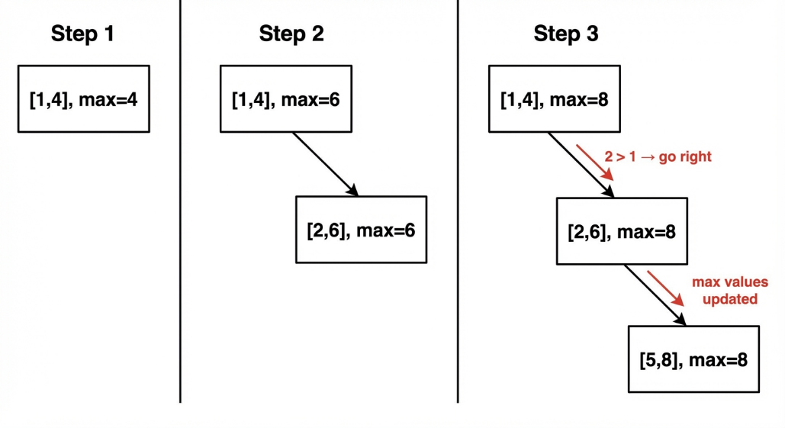
1. Insert [1,4]
[1,4], max=4

2. Insert [2,6]
2 > 1 → go right

3.Insert [5,8]
5 > 1 → right
5 > 2 → right

How do we check overlap?
Two intervals [L1, H1] and [L2, H2] overlap if: L1 ≤ H2 AND L2 ≤ H1
Logic Behind it:
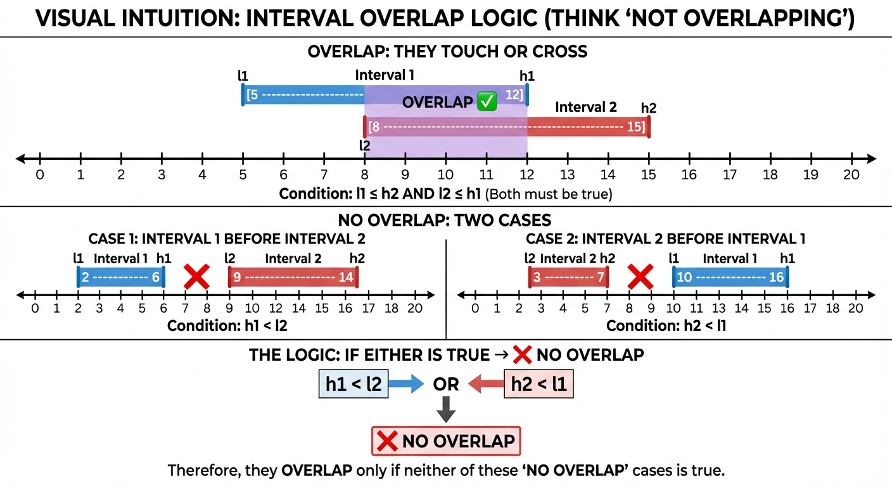

Example-1:
[2,6] and [3,5] → overlap as 2 ≤ 5 and 3 ≤ 6

Example-2:
Query interval: [3,5]
Start at root [1,4]
Check overlap: [1,4] overlaps [3,5] → YES
So we’re done.

If we did not find overlapping interval at root node, we will move to next node ( either left ot right ) based on max value

Let
Node interval: [L1, H1] , Query interval: [L2, H2]
Step 1: Check overlap
We are at a node storing interval: [L1, H1]
We are searching for overlap with query: [L2, H2]
IF (L1 ≤ H2 AND L2 ≤ H1)
→ FOUND overlap
→ STOP search

Step 2: Decide where to search next
If no overlap at current node, we must decide:
- go LEFT
- or RIGHT
This is where max helps.

IF (LEFT exists AND LEFT.MAX ≥ L2)
search LEFT
ELSE
search RIGHT
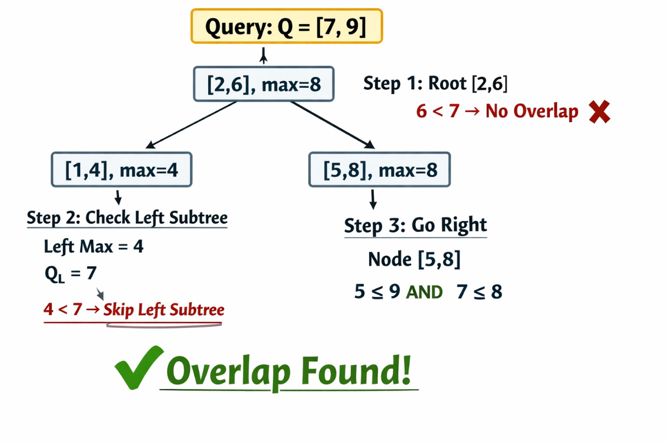
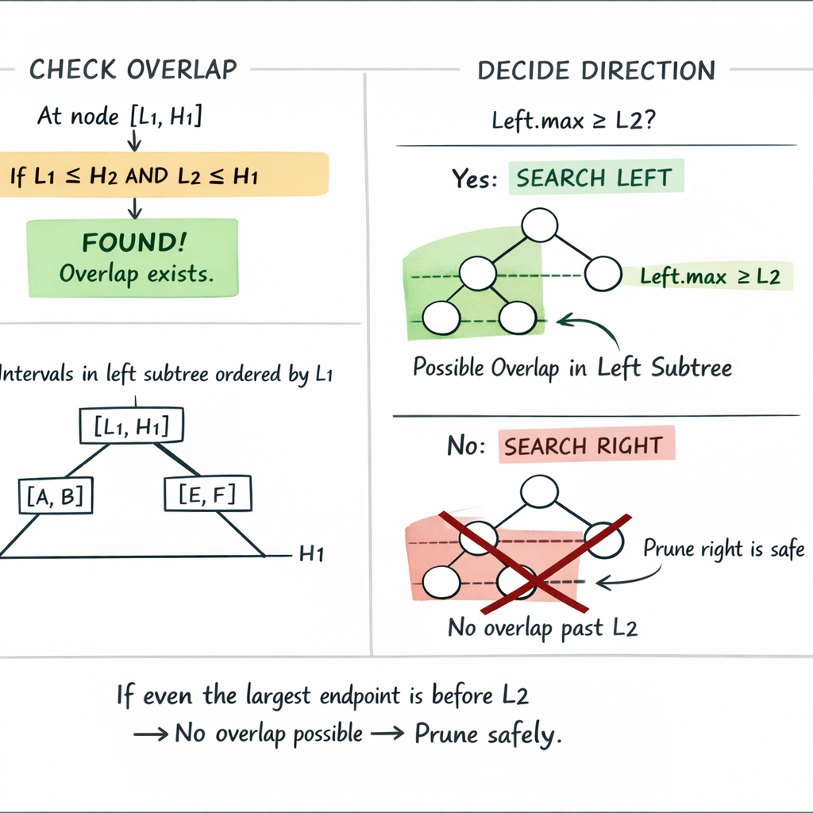

Why this avoids O(n) ?
Without max:
- You must visit both subtrees
- You can’t rule anything out
With max:
- You eliminate entire subtrees in one comparison
So average time: O(log n)
Worst case (unbalanced tree): O(n)

Pseudo Code
Overlap checking function :
FUNCTION overlap(i1, i2):
IF i1.low ≤ i2.high AND i2.low ≤ i1.high:
RETURN true
ELSE:
RETURN false

Insert an interval into the interval tree
Logic:
- Insert like a BST using low
- Update max while returning
FUNCTION insert(root, interval):

IF root == NULL:
CREATE new node
node.low = interval.low
node.high = interval.high
node.max = interval.high
node.left = NULL
node.right = NULL
RETURN node

IF interval.low < root.low:
root.left = insert(root.left, interval)
ELSE:
root.right = insert(root.right, interval)

// update max value
root.max = MAX(root.max, interval.high)

RETURN root

The interval tree is essentially a BST (Binary Search Tree) ordered by the start of intervals, i.e., low.
- Left subtree: intervals with low < root.low
- Right subtree: intervals with low ≥ root.low
We don’t compare high for placement — that’s why max exists separately.

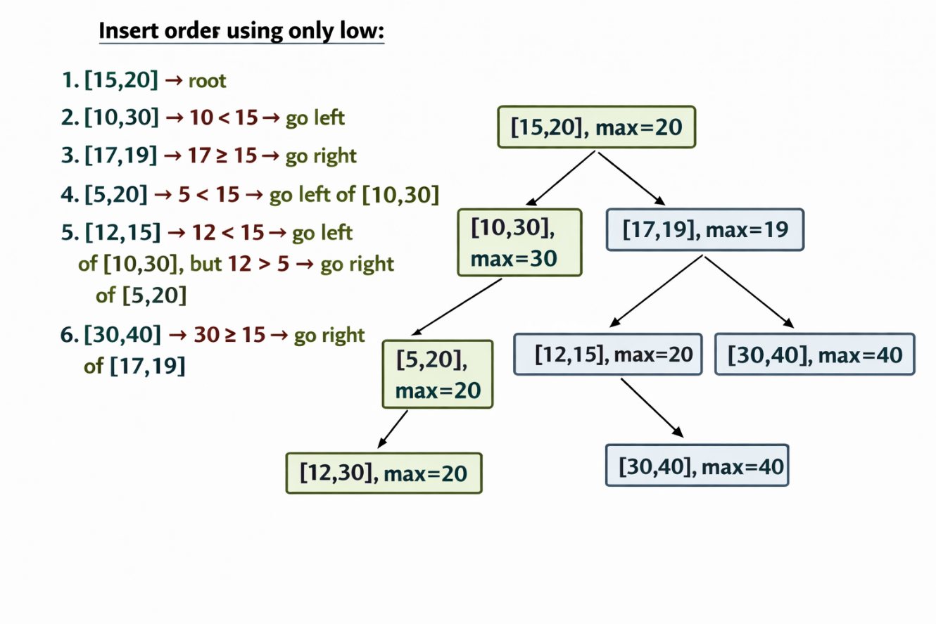

Search for an overlapping interval
Goal: Find any one interval that overlaps with the query.

FUNCTION searchOverlap(root, query):

IF root == NULL:
RETURN NULL

// Step 1: Check overlap at current node
IF overlap(root.interval, query):
RETURN root.interval

// Step 2: Decide where to go using max
IF root.left != NULL AND root.left.max ≥ query.low:
RETURN searchOverlap(root.left, query)

ELSE:
RETURN searchOverlap(root.right, query)

